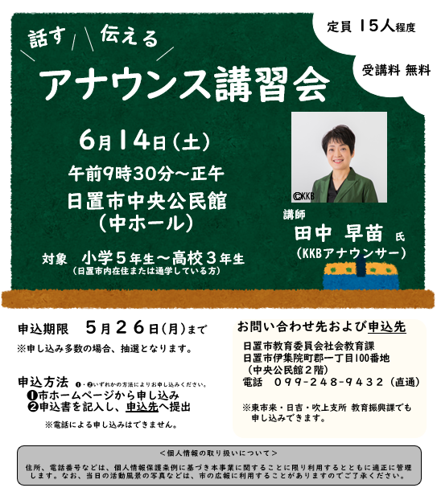

**キリトリセン**

**アナウンス講習会申込書**

|  |  |  |  |
| --- | --- | --- | --- |
| **ふりがな** |  | **所属校名** | **学年** |
| **お名前** |  |  | **年** |
| **住所** | **〒** | | |
| **電話番号** |  | | |